E-Marketing Plan on The Salvation Army
Student’s Name
Institutional Affiliations

Table of Contents
Executive Summary 2
E-Marketing Plan on The Salvation Army 4
Background Information and Description of the Organization 4
Strategic Analysis 5
The Threat of New Entrants 5
The Threat of Substitutes Programs or Denomination 5
The Bargaining Power of the Organization 6
The Intensity of Competitive Rivalry 6
Marketing Objectives 8
Expansion of the Organization in Different Countries 8
Emergency Disaster Services 8
To Engage in Housing Program 8
To Increase Efforts to Curb Human Trafficking 9
To Spread Out of Organizational Finances 9
Public Information Advocacy 9
Strategies and Tactics for Achieving the Objectives 10
Web Marketing 10
Social Networks and Social Media Marketing 10
Online and on the Ground Campaigns 11
Participating in Public Policy Formation 11
Strategy Evaluation/SWOT Analysis 12
Strengths 12
Weaknesses 13
Opportunities 13
Threats 14
Implementation of strategies 17
Tracking, Analyzing and Optimization of Data 17
References 19

Executive Summary
Salvation Army is a Christian Organization striving to win more people to join the congregation in its quest to achieve eternal life after death. Just as any other non-profit organization, it has to carefully plan and execute strategic plans to ensure its continuity. That is why it needs strategic planning. The competitive position of Salvation of Army is rather daunting due to the existence of giant Christian organizations and ministries. The biggest one being the Catholic church which has a bigger bargaining power for the members of the society. Furthermore, religious activities are open for new entrants this present competition for the Salvation Army. However, all is not lost as the organization can use social media platforms, campaigns and expansion of branches to help it grow its membership. The weaknesses, however, are that the organization is not yet established and it is viewed as very strict which scares some pope from joining. Nonetheless, the existing movement of people from one religious group to another presents an opportunity for Salvation Army to tap in. Furthermore, the fact that the organization has a leadership structure already in place makes it easy to make and implement strategic plans regarding expansion. Despite the opportunities, the Salvation Army is threatened by the existence of rivals such as Cat holism and Islamic religion which are also seeking to win over the members of the society. Therefore, the objectives of the company should be to expand, train more leaders and build more churches across the country and across the world and getting involved in charity work to win more people. To achieve this, there is a need to deploy more ambassadors out there to proclaim the word of God under the umbrella of the Salvation Army. More finances will also be needed for the construction of churches. Campaigns and crusades can help with this quest. Most important however is that the strategies are evaluated to determine their success after being implemented and this can be done by checking and tracking the success rate for strategies that the organization uses in meeting the objectives of the plan.

E-Marketing Plan on The Salvation Army
This is an E-Marketing Plan on the Salvation Army which is meant to offer insight on how the organization can achieve expansion and growth and create competitive advantage for itself.

Background Information and Description of the Organization
Salvation Army is a non-profit organization and a global protestant denomination with over a million members in 109 countries (Merritt & Satterlee, 2017). The organization was founded in the year 1865 by William Booth who at that time was an evangelist and had a passion for not only helping the poor and the destitute but also for preaching the gospel to them. The organization was originally known as a Christian missionary but in the year 1878, it officially became Salvation Army. The main mission of the organization is to promote charity work. It is famous for helping the underprivileged in society. For instance, taking care of the elderly, providing shelter to the homeless (Merritt & Satterlee, 2017).
As observed over the years, religion is a growing industry. The success of the organization depends on the model of how marketing is being utilized. Salvation Army is making a difference in the communities they serve and attracting more and more people into their organization. The organization foundation of marketing is established in the context of whom they are trying to reach, in this case, the organization main target is people who are looking for an institution that speak their deepest needs for social and spiritual needs. Salvation Army has become involved in the marketing of their biblical relevant programs that speak to those needs (Merritt & Satterlee, 2017). Such programs may include relationship marketing where they provide services that help people develop better relationships with others and most importantly themselves. A strategic marketing plan needs to be formulated so that it can develop a plan that maintains a strategic fit between the organization goals, resources, and its changing marketing opportunities. Salvation Army operates in the context of the Christian religion with a keen eye to promoting life standards for the underprivileged in society by reaching out to them.

Strategic Analysis/Porter’s Five Forces
Strategic analysis is a framework that attempts to analyze the level of development within an organization and the plan that they use (McDonald, 2016). It shows the intensity at which an organization attracts its audience (McDonald, 2015). In regards to the Salvation Army, they target people in their organization and members who want to join them. To do this, they need to apply unique strategies to achieve its mission. To determine the threats and assess the context of the market and prospect some risks had to be analyzed in regards to the organization. Analysis in this section follows Porter’s Five Forces Model

The Threat of New Entrants
It is important to note that every day there is a rise of a new denomination which has the same mandate as Salvation Army and this new entrant may decrease the number of people in the denomination if the organization does not introduce incumbents. This means that they should create more programs which may be of more benefit to the people and this prevents any member from migrating to new entrants since the services and program present in salvation army cannot be found elsewhere.

The Threat of Substitutes Programs or Denomination
Services offered by the organization exist outside its boundaries. This can increase the propensity of their members switching to the alternatives. For example, the Salvation Army is widely known for offering medical services to disaster victims (Dobocan, 2015). The same services are offered by an organization such as the Red Cross. There is a probability of members preferring Red Cross is since it’s widely known for the services and has no religious affiliations. The best way to promote the organization services is by strengthening the quality given and promoting employee’s solidarity. Creation of awareness about their programs is also another method of attracting new people in their organization.

The Bargaining Power of the Organization
The bargaining power of organization comes in terms of the services offered. This is a crucial strategy when targeting new members. The type of services offered can be a source of power when they are few people offering the services (Dadzie et al., 2017). Salvation Army is a denomination that is more concerned with community building. They develop community infrastructures such as hospital and elderly homes. They deploy their staff to work there. Their services become a power source of attaining partnership and collaboration between different organizations. The institutions and the community people are attracted to the organization because of these activities.

The Intensity of Competitive Rivalry
The competitive advantage for Salvation Army is minimal in society given that there exist rival religious organizations that are seeking to win souls and people. Some of the organizations have a stronger influence and a larger number of members including the Catholic church and other ministries. Therefore, the competitive position of the Salvation army is rather diminished by this rivalry that exists in society. Competition may arise between different institutions. An organization other than the Salvation Army may receive the definition and legitimating when community officials sign statements that declare the organization the official relief institution. The Salvation Army operations may be hindered since the organization may decide to block their efforts in helping the community. However, different strategies may be formed to curb this competition; this includes the creation of strong social association and relation with the community within its operation (Dobocan, 2015). Although the organization itself is a religious group, it has managed to control competition with other associations. Working closely with the community and different organization has gained its recognition in the community.
The diagram below is a presentation of the Porter’s Five Forces
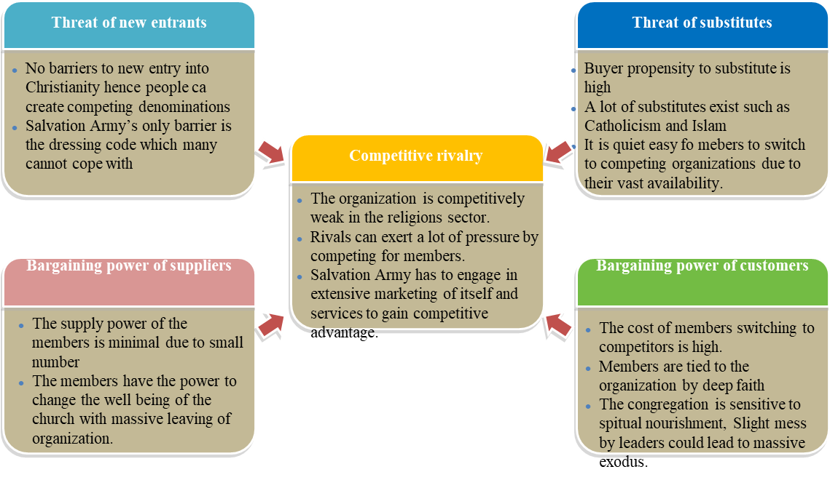

Marketing Objectives

Expansion of the Organization in Different Countries
Increasing community centers may be among the objectives that can be set in the strategic plan. The diversification of different programs will enhance Army effectiveness in spreading into different countries. Officers and volunteers have a big impact and they connect a worldwide network. Expansion of the organization will lead improvement of health, economic and spiritual conditions for the people who may be underprivileged and cannot acquire these services.

Emergency Disaster Services
Disaster may strike in different forms, either man-made or natural. There is a need to be on the scene because communities are largely affected by the disasters. With the concern of people needs as its priority, an increase in the number of emergency units in the different region should be an objective so that it can be the first to arrive when the disaster strikes. Mobile emergency feeding units are also important when disaster comes. This can help to win more membership for the Salvation Army.

To Engage in Housing Program
Free temporally shelter should be available to any of the homeless men, women or children. Creation of low-cost houses should be available to those people living on pensions or social security. This should be an objective for this organization and when life in most dire, the organization should be known to be a trusted and compassionate place for refuge. Trying to achieve this objective should help the organization to win more people to join the congregation of the Salvation Army.

To Increase Efforts to Curb Human Trafficking
According to the International Labor Organization, more than 20 million people are victims of human trafficking (Munro, 2019). Salvation Army over the years has been fighting human trafficking since it has been historically rooted under the leadership of the Catherine and William the founders (Merritt & Satterlee, 2017). They both rescued women and girls who were caught up with sexual exploitation. Efforts to increase the fight against human trafficking should be put in place so that people are treated with dignity and they are given the authority to live life in an in a self-determined way.

To Spread Out of Organizational Finances
More than 10million people benefit from the organization finances. This is through the Salvation Army Foundation and corporation. The main mandate of the Army is to meet the social service needs of the local communities. According to O'Brien (2018), the Salvation Army is termed as the most charitable organization among the existing Christian denominations. However, there is a need to spread out their finances so that there can be an increase in programs that are supported by voluntary contributions. Supplementary fund-raising programs are supported by the organization finances, and a steady increase of this will perpetuate more people benefitting from it.

Public Information Advocacy
As technological advancement has progressed, the organization needs to keep up with the pace of modern communication so that it can effectively convey its message. The need to use the current media to rely on their gospel is important since it is a powerful tool that introduces a wide coverage. This will enable the organization to tell their gospel stories and valuable information through the use of videos which are circulated in schools, churches, services and other community groups.

Strategies and Tactics for Achieving the Objectives

Web Marketing
The use of internet digital technology enhances and develops marketing attributes. The Internet has commercialized the world. The organization can use the internet as an effective medium to advertise their services and programs. This is because digital platforms are effective in reaching more people at a lower cost (West, Ford & Ibrahim, 2015). Salvation Army can put their information in their website since the website is a platform that people use since it’s cheaper and it is easier to acquire any information needed, it offers a variety of services that may be of use to a person. A banner can be hyperlinked to a website and this provides a specific structure and content of information that the organization wants to pass. It is also easier for members to grasp the information present in a banner. In a case that the banner is colourful it is likely to attract more people and consequently, have more rate of clicking.

Social Networks and Social Media Marketing
Social media marketing will involve text, video, and network from the organization to members and vice versa. Social media platforms tend to facilitate interaction between users and can create a lot of traffic and attention to an organization being advertised (West, Ford & Ibrahim, 2015). Social media may take different forms such as weblogs, wikis, videos, and pictures. Salvation Army can use this type of marketing as a communication tool to their members and especially the youths who are the common users of these forums. Trained officers and skilled personnel in the organization should use this method to broadcast their information. Furthermore, this form of marketing achieves more members in the organization since it understands their needs and there is a need to fulfil them, based on the information that may be acquired from this platform.

Online and on the Ground Campaigns
The use of campaigns is necessary, campaigns may be of help in fund-raising which is fundamental to an organization since different programs are supported through the finances collected. Promotion of more gift annuities and charitable trust campaigns provide more income through the planned agreements. The steady number of campaigns increases the number of people who are more concerned about the welfare of others in the society this offers an extensive increase in financial assistance. Campaigns also create awareness about the programs and services offered in the organization and this creates a spark of interest to people who may require the services, from counselling to quality medical facilities.

Participating in Public Policy Formation
The organization is dedicated to fighting different vices in the community. This may include human trafficking (Munro, 2019). However, the Salvation Army should be involved in planning and supporting any policy that is meant to curb the problem. The organization has a strong member following and so they should be the creation of a strong fervor to foment any public opinion regarding any law that is against social justice. Variety of services should be introduced in response to any victim of any social injustice. Education to the public through the organization is paramount so that they can have substantive knowledge of its reality.

Strategy Evaluation/SWOT Analysis
The evaluation of the marketing strategies is used as an instrument to determine both the internal and external conditions that have a direct or indirect effect on the wellbeing of the organization (Gürel & Tat, 2017). To effectively evaluate the strategy, SWOT analysis can be done to determine the Strengths, weakness opportunities and threats to the organization.

Strengths
Salvation Army as an organization has some strengths that present a lot of expansion opportunities for it. One of the strengths is that its congregation is more willing to continue with the quest for expansion through undertaking campaigns of spreading the gospel. Having a willing workforce and members is a plus for this organization and it means that the organization can easily find ambassadors of among its membership to spread its wings to other towns where the Salvation Army churches are not yet established.
Another strength is that the organization already has a leadership structure that runs the affairs of the organization. There is a hierarchical structure through which instructions follow and trickle down to the members or the congregation of the Salvation Army. This structure is a strength because it means that the leadership of the organization is already in existence and expansion of the organization can be well structured to reach a peak level.
Salvation Army has a membership that exhibits strong religious beliefs in the church and this is a strength for this organization. All over the county, the members of the Salvation Army are known to strictly observe their dressing code whenever they attend their church services. This is a clear indication that the beliefs of this religious group are deeply inculcated in its congregation and therefore, it is hard for one to leave salvation Army for another religious group.

Weaknesses
Despite the above stipulated strengths, Salvation Army as an organization exhibits some weaknesses too. One of the weaknesses is that the organization is too strict on matters religion and this might prove it difficult to win more members to join its congregation. One factor that exhibits strictness is the dress code. Salvation Army members have to dress in police-like attire to adhere to the dressing code of the church. This might be awkward for some people who might be seeking to join this organization. Therefore, the culture and beliefs of the group might lock out some people who might be willing to join and yet are not ready to get accustomed to such beliefs and practices.
Another weakness is that the organization has not yet established many branches compared to its competitors in the country and all over the world. Salvation Army churches are often countable in many areas and in some towns, they are missing completely and this means that they have to invest a lot in constructing churches in many areas which might require a lot of finances. The fact that the organization has not spread its wings compared to other religious groups in society is a weakness for the organization. Furthermore, due to the slim membership, the organization is not financially endowed to take on moves to actualize its strategic plan.

Opportunities
There exists a lot of opportunities for the Salvation Army as a religious organization that is keen on expanding more and more and spreading its wings all over and increasing the number of their members. One of the opportunities is the existence of a lot of orthodox religious groups that unscrupulous religious groups that are deviating from the Christianity path today. In the United States of America and even in other countries, there are many religious groups that claim to practice Christianity but their practices deviate from the principles that govern Christianity. As such, people are always on the move from one religious group to another in such of a compatible religious group to fit in. Salvation Army can be a destination for some of them and this presents an opportunity for Salvation Army to expand the number of its members.
Another opportunity is the conflict that exists between the giant religious organizations such as the conflict between Protestant Churches such as The Anglican Church and Catholics. A good number of people do not want to find themselves in the mix of these conflicts and so they choose to join organizations that are less involved in religious conflicts such as the Salvation Army. This is an opportunity for growth of the Salvation Army.

Threats
Despite the existing opportunities, Salvation Army is faced with challenges and the biggest threat is the existence of competing religions in the United States of America. Salvation Army is a religious group that seeks to convert more people to their religious traditions and practices. However, Catholicism and Islam, as well as other Christian ministries that exist in society today, present a challenge and a threat to the Salvation Army. Many people shift from Salvation Army to join other religious groups and this threatens the continuity of the group.
Another threat has to do with the existing religious ideologies that view Salvation Army congregation as misguided and extremely religious. Other religious such as Catholic church have given their congregation freedom in terms of dressing code and therefore, their contemporary Christian ideologies are in most cases in conflict with those practiced and held by the Salvation Army members. This is a threat because people move for other religions which can allow them to exercise freedom regarding cultural issues such as dress code.
The diagram below is a diagrammatic presentation of The Salvation Army SWOT Analysis
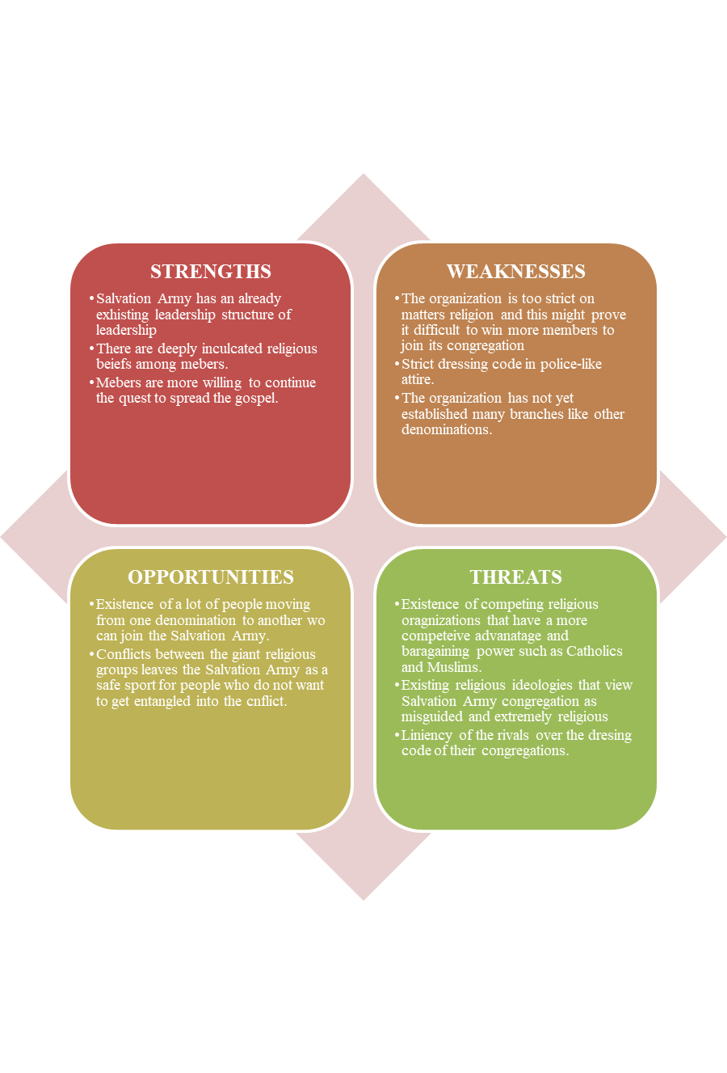

Implementation of strategies
Marketing implementation can be described as the process that turns marketing strategies into actual assignments and ensuring that the plans are executed in a manner that accomplishes the plans and objectives that had been set (West, Ford & Ibrahim, 2015). Some of the implementations in the Salvation Army plan include Proper training of officials who will be associated with the programs initiated. Recruiting and developing new members and organization leaders into the organization, advertising organizational information through proposed channels of communication can also help to implement their strategic goals and organizational objectives. Organizing crusades and campaigns will be used to gain more funds for the expansion of the organization through initiatives such as building more churches in areas where the organization is not yet established. This has to be done by assessing regions in which the expansion of new Salvation Army centers will be developed.

Tracking, Analyzing and Optimization of Data
Data from all the activities implemented should be collected so that it is verified and documented for correct decision making by the leadership of the organization. Data collected is used to determine the number of new members that have joined the church organization. Compare the amount of financial resources generated before and after the development of the plan implementation. With this data, the organization can point out recommendations that are needed to be done in specific fields. Salvation Army can track progress by looking at the rate of conversion which can be seen through the percentage of increase in the number of people joining the denomination. Analysis of strategies applied to achieve objects can be done by looking at the success rate for each approach. In conclusion, the marketing strategy plan for the Salvation Army should largely focus on identifying the target audience and aim at the expansion of the organization.

References
Dadzie, K. Q., Amponsah, D. K., Dadzie, C. A., & Winston, E. M. (2017). How firms implement marketing strategies in emerging markets: An empirical assessment of the 4A marketing mix framework. Journal of Marketing Theory and Practice, 25(3), 234-256.
Dobocan, F. C. (2015). Religious Marketing–A Means of Satisfying Parishioners' Needs and Determining their Loyalty. Journal for the Study of Religions and Ideologies, (40), 112-130.
Gürel, E., & Tat, M. (2017). SWOT analysis: A theoretical review. Journal of International Social Research, 10(51).
McDonald, M. (2015). Marketing accountability. Wiley Encyclopedia of Management, 1-8.
McDonald, M. A. L. C. O. L. M. (2016). Strategic marketing planning: theory and practice. In The marketing book (pp. 108-142). Routledge.
Merritt, J. G., & Satterlee, A. (Eds.). (2017). Historical dictionary of the Salvation Army. Rowman & Littlefield.
Munro, G. (2019). The NGO Response to Human Trafficking: Challenges, Opportunities, and Constraints. The Palgrave International Handbook of Human Trafficking, 1-13.
O'Brien, G. (2018). Holiness at the ends of the earth: The Salvation Army in Australia. In Wesleyan-Holiness Churches in Australia (pp. 47-68). Routledge.
West, D. C., Ford, J., & Ibrahim, E. (2015). Strategic marketing: creating competitive advantage. Oxford University Press, USA.

